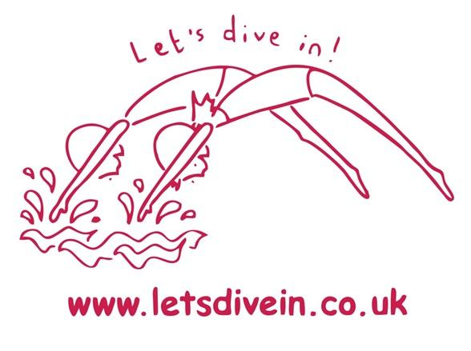
Let’s Dive In!
CUSTOMER PRIVACY NOTICE

This privacy notice tells you what to expect us to do with your personal information.

- Contact details
- What information we collect, use, and why
- Lawful bases and data protection rights
- Where we get personal information from
- How long we keep information
- Who we share information with
- How to complain

1. CONTACT DETAILS

Telephone: 07966 937101
Email: info@letsdivein.co.uk

2. WHAT INFORMATION WE COLLECT, USE, AND WHY

We collect or use the following information for student education and welfare:
- Names and contact details for students/children
- Names and contact details for parents, guardians, carers
- Gender
- Pronoun preferences
- Date of birth
- Next of kin and emergency contact information
- Payment details and financial information including transactions
- Special Educational Needs and Disabilities (SEND) or additional support information (includes reasonable adjustments and special educational needs and disabilities)
- Welfare information (includes family and home life circumstances and history)
- Photographs
- Attendance and reason for absence data
- Progress reports
- Information relating to compliments and complaints
- Exclusion, suspension and behavioural information

We also collect or use the following special category information for student education and welfare. This information is subject to additional protection due to its sensitive nature:
- Health information

We collect or use the following personal information for dealing with queries, complaints or claims:
- Names and contact details
- Payment details
- Purchase or service history
- Witness statements and contact details
- Information relating to health and safety (including incident investigation details and reports and accident book records)
- Special Educational Needs and Disabilities (SEND) or additional support information (includes reasonable adjustments and special educational needs and disabilities)
- Attendance and reason for absence data

We also collect the following special category information for dealing with queries, complaints or claims. This information is subject to additional protection due to its sensitive nature:
- Health information

We collect or use the following information for information updates or marketing purposes:
- Names and contact details
- Addresses
- Marketing preferences
- Photographs
- Records of consent, where appropriate

We collect or use the following information to comply with legal requirements:
- Identification documents
- Health and safety information
- Criminal offence data (including Disclosure Barring Service (DBS), Access NI or Disclosure Scotland checks)
- Safeguarding information
- Any other personal information required to comply with legal obligations

We also collect or use the following special category information to comply with legal requirements. This information is subject to additional protection due to its sensitive nature:
- Health information

3. LAWFUL BASES AND DATA PROTECTION RIGHTS
Under UK data protection law, we must have a “lawful basis” for collecting and using your personal information. There is a list of possible lawful bases in the UK GDPR. You can find out more about lawful bases on the ICO’s website.
Which lawful basis we rely on may affect your data protection rights which are set out in brief below. You can find out more about your data protection rights and the exemptions which may apply on the ICO’s website:
- Your right of access - You have the right to ask us for copies of your personal information. You can request other information such as details about where we get personal information from and who we share personal information with. There are some exemptions which means you may not receive all the information you ask for. Read more about the right of access.
- Your right to rectification - You have the right to ask us to correct or delete personal information you think is inaccurate or incomplete. Read more about the right to rectification.
- Your right to erasure - You have the right to ask us to delete your personal information. Read more about the right to erasure.
- Your right to restriction of processing - You have the right to ask us to limit how we can use your personal information. Read more about the right to restriction of processing.
- Your right to object to processing - You have the right to object to the processing of your personal data. Read more about the right to object to processing.
- Your right to data portability - You have the right to ask that we transfer the personal information you gave us to another organisation, or to you. Read more about the right to data portability.
- Your right to withdraw consent – When we use consent as our lawful basis you have the right to withdraw your consent at any time. Read more about the right to withdraw consent.
If you make a request, we must respond to you without undue delay and in any event within one month.
To make a data protection rights request, please contact us using the contact details at the top of this privacy notice.
Our lawful bases for the collection and use of your data
Our lawful bases for collecting or using personal information for student education and welfare are:
- Consent - we have permission from you after we gave you all the relevant information. All of your data protection rights may apply, except the right to object. To be clear, you do have the right to withdraw your consent at any time.
- Legal obligation - we have to collect or use your information so we can comply with the law. All of your data protection rights may apply, except the right to erasure, the right to object and the right to data portability.
- Vital interests - collecting or using the information is needed when someone’s physical or mental health or wellbeing is at urgent or serious risk. This includes an urgent need for life sustaining food, water, clothing or shelter. All of your data protection rights may apply, except the right to object and the right to portability.

Our lawful bases for collecting or using personal information for dealing with queries, complaints or claims are:
- Consent - we have permission from you after we gave you all the relevant information. All of your data protection rights may apply, except the right to object. To be clear, you do have the right to withdraw your consent at any time.
- Legal obligation - we have to collect or use your information so we can comply with the law. All of your data protection rights may apply, except the right to erasure, the right to object and the right to data portability.
- Vital interests - collecting or using the information is needed when someone’s physical or mental health or wellbeing is at urgent or serious risk. This includes an urgent need for life sustaining food, water, clothing or shelter. All of your data protection rights may apply, except the right to object and the right to portability.

Our lawful bases for collecting or using personal information for information updates or marketing purposes are:
- Consent - we have permission from you after we gave you all the relevant information. All of your data protection rights may apply, except the right to object. To be clear, you do have the right to withdraw your consent at any time.

Our lawful bases for collecting or using personal information to comply with legal requirements are:
- Consent - we have permission from you after we gave you all the relevant information. All of your data protection rights may apply, except the right to object. To be clear, you do have the right to withdraw your consent at any time.
- Legal obligation - we have to collect or use your information so we can comply with the law. All of your data protection rights may apply, except the right to erasure, the right to object and the right to data portability.
- Vital interests - collecting or using the information is needed when someone’s physical or mental health or wellbeing is at urgent or serious risk. This includes an urgent need for life sustaining food, water, clothing or shelter. All of your data protection rights may apply, except the right to object and the right to portability.

4. WHERE WE GET PERSONAL INFORMATION FROM

- Directly from you
- Parents or carers

5. HOW LONG WE KEEP INFORMATION
Personal information is stored in line with GDPR policy and is kept for the duration of LDI operations. All users which registered with Mor Solutions our software provider for our swimming database is stored in line with their Privacy policy. Their policy can be found at: https://swimsoft.co.uk/privacy-policy
6. WHO WE SHARE INFORMATION WITH
Others we share personal information with
- Organisations we need to share information with for safeguarding reasons and MorSolutions, database provider.
7. HOW TO COMPLAIN
If you have any concerns about our use of your personal information, you can make a data protection complaint to us:
Email: info@letsdivein.co.uk
If you remain unhappy with how we’ve used your data after raising a complaint with us, you can also complain to the ICO.
The ICO’s address:
Information Commissioner’s Office
Wycliffe House
Water Lane
Wilmslow
Cheshire
SK9 5AF
Helpline number: 0303 123 1113
Website: https://www.ico.org.uk/make-a-complaint

